Assignment

Module 1 (Fundamental)

1. **What is SDLC?**

**Ans.**

SDLC is a structure imposed on the development of a software product that defines the process for planning, implementation, testing, documentation, deployment, and ongoing maintenance and support. There are a number of different development models.

1. **What is software testing?**

**Ans.**

Software Testing is a process used to identify the correctness, completeness, and quality of developed computer software.

1. **What is agile methodology?**

**Ans.**

Agile SDLC model is a combination of iterative and incremental process models with focus on process adaptability and customer satisfaction by rapid delivery of working software product.

1. **What is SRS?**

**Ans.**

A software requirements specification (SRS) is a document that describes what the software will do and how it will be expected to perform. It also describes the functionality the product needs to fulfil the needs of all stakeholders (business, users).

1. **What is oops?**

**Ans.**

Object oriented programming is way of writing the programs in organized way, provides security, redundancy etc.

Object are like a black box where data are hidden.

1. **Write Basic Concepts of oops?**

**Ans.**

1. class
2. Object
3. Inheritance
4. Polymorphism: - (I) Over ridding (II) Over loading
5. Encapsulation
6. Abstraction.

1. **What is object?**

**Ans.**

Object gives the permission to access functionality of class.

1. **What is class?**

**Ans.**

Class is a collection of data member and member function.

Int a=10, b=20

1. **What is encapsulation?**

**Ans.**

The process wrapping the data in a single unite to secure the data from outside world.

1. **What is inheritance?**

**Ans.**

Making class from an existing class, deriving the attribute of some other class.

1. **What is polymorphism?**

**Ans.**

Polymorphism means “having many forms”.

It allows different objects to respond to the same message in different ways, the response specific to the type of the object.

1. **Draw Use case on Online book shopping.**

**Ans.**

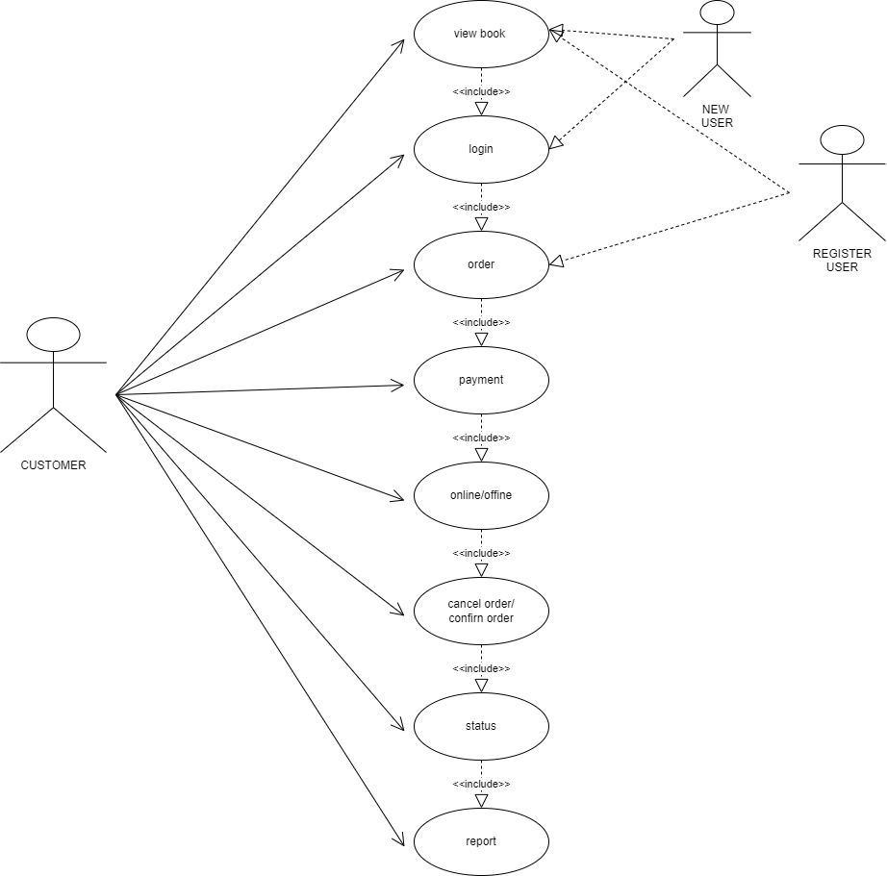

1. **Draw Use case on online bill payment system (Paytm).**

**Ans.**

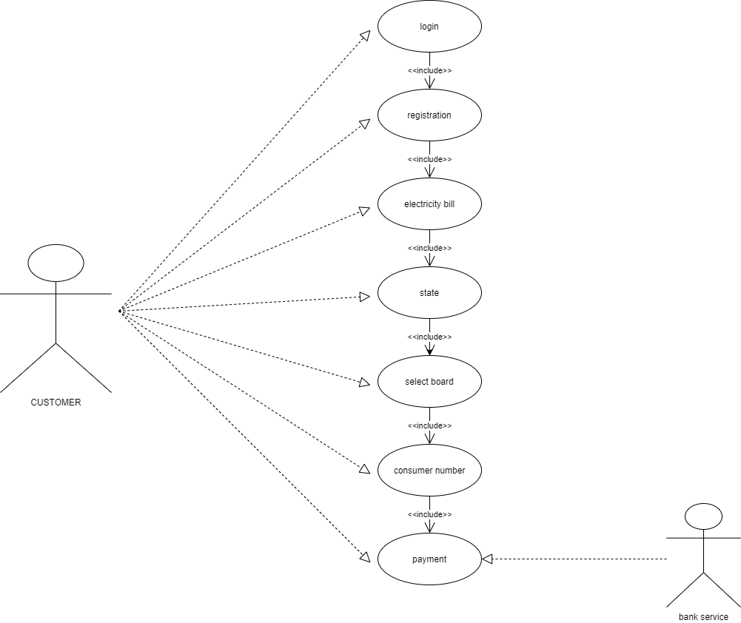

1. **Write SDLC phases with basic introduction.**

**Ans.**

SDLC is a structure imposed on the development of a software product that defines the process for planning, implementation, testing, documentation, deployment, and ongoing maintenance and support. There are a number of different development models.

|  |  |
| --- | --- |
| Requirements Collection/Gathering | Establish Customer Needs |
| Analysis | Model And specify the requirements- “What” |
| Design | Model And Specify a Solution – “Why” |
| Implementation | Construct a Solution in Software |
| Testing | Validate the solution against the requirements |
| Maintenance | Repair defects and adapt the solution to the new requirements |

1. **Explain Phases of the waterfall model.**

**Ans.**

* **The waterfall is unrealistic for many reasons, especially:**
* **Requirements must be “frozen” to early in the life cycle**
* **Requirements are validated too late**

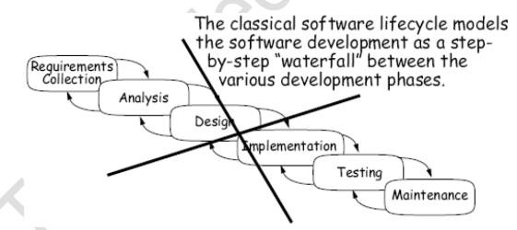

1. **Write phases of spiral model.**

**Ans.**

**Bohem’s Spiral Model/Methodology**

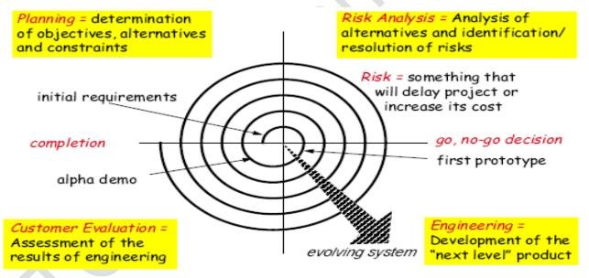

1. **Write agile manifesto principles.**

**Ans.**

-> Individuals and interactions - in agile development, self-organization and motivation are important, as are interactions like co-location and pair programming.

-> Working software - Demo working software is considered the best means of communication with the customer to understand their requirement, instead of just depending on documentation.

-> Customer collaboration - As the requirements cannot be gathered completely in the beginning of the project due to various factors, continuous customer interaction is very important to get proper product requirements.

-> Responding to change - agile development is focused on quick responses to change and continuous development.

**18. Explain working methodology of agile model and also write pros and cons.**

**Ans.**

Agile SDLC model is a combination of iterative and incremental process models with focus on process adaptability and customer satisfaction by rapid delivery of working software product.

# Agile Model Work Flow

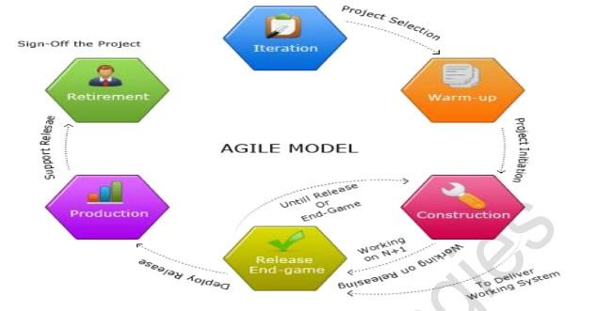

**Pros: -**

* Is a very realistic approach to software development
* Promotes teamwork and cross training.
* Functionality can be developed rapidly and demonstrated.
* Resource requirements are minimum.
* Suitable for fixed or changing requirements
* Delivers early partial working solutions.
* Good model for environments that change steadily.
* Minimal rules, documentation easily employed.
* Enables concurrent development and delivery within an overall planned context.
* Little or no planning required
* Easy to manage
* Gives flexibility to developers
* **Cons: -**
* Not suitable for handling complex dependencies.
* More risk of sustainability, maintainability and extensibility.
* An overall plan, an agile leader and agile PM practice is a must without which it will not work.
* Strict delivery management dictates the scope, functionality to be delivered, and adjustments to meet the deadlines.
* Depends heavily on customer interaction, so if customer is not clear, team can be driven in the wrong direction.
* There is very high individual dependency, since there is minimum documentation generated.
* Transfer of technology to new team members may be quite challenging due to lack of

1. **Draw use case on Online shopping product using COD.**

**Ans.** 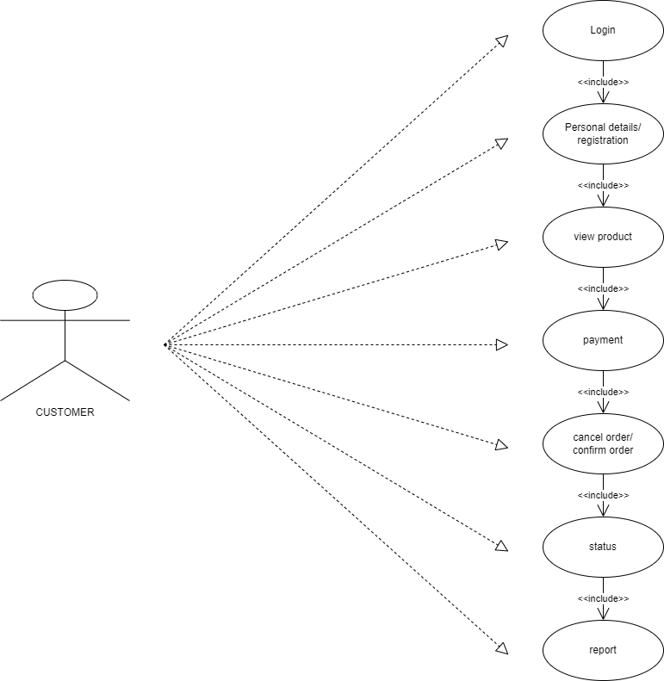

1. **Draw use case on Online shopping product using payment gateway.**

**Ans.**

